**Performed by:**

**Saurabh Jadhav : 192010045**

**Trupti Tekawade : 192011063**

**Shriram Bhagwatkar : 192010051**

**Experiment No .10** : Implementation: Final (End-to-End).

This is a personal photography company where people are able to see the artwork of the photographers and can book the events we provide.

**Home Page**

This is what a customer will see when he/she enters our website.

This is the home page of our website.

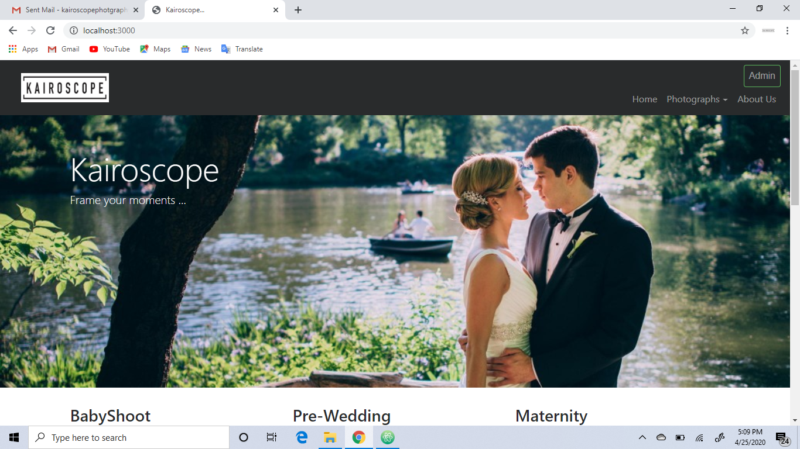

**Services :**

Here are some services we provide to our customers i.e shoot for Pre-wedding, Wedding , Engagement ,Maternity, Baby shoot.

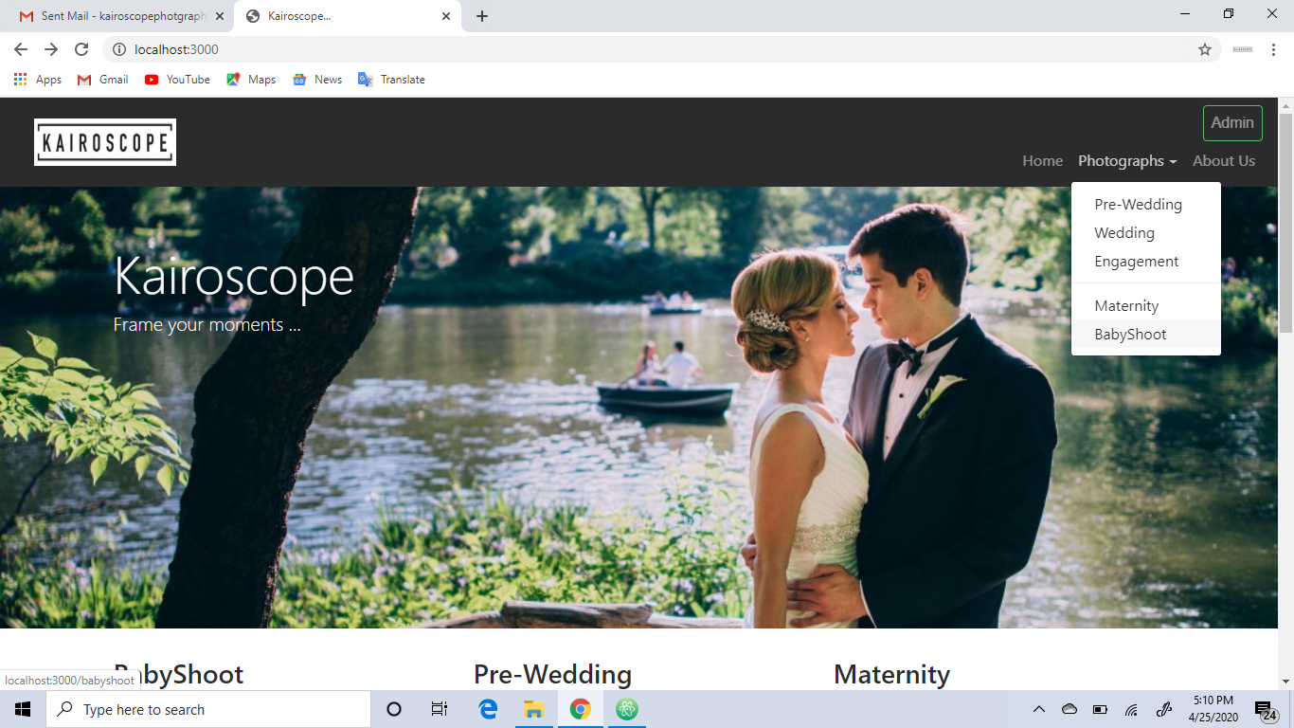

Like you can see in the below picture that when the customer chooses one of the event type, we display the photographer’s work for reference to them

When the customer likes the work of the client, he/she books the photographer by clicking the book photographer button.

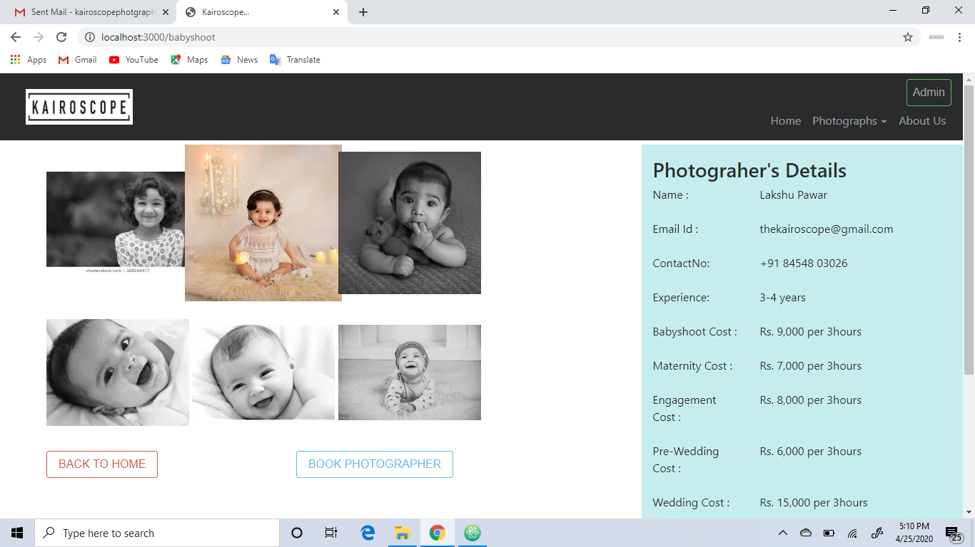

After clicking the book photographer button, the customer is navigated to the following page in order to fill his and event details, for which the customer is booking the photographer.

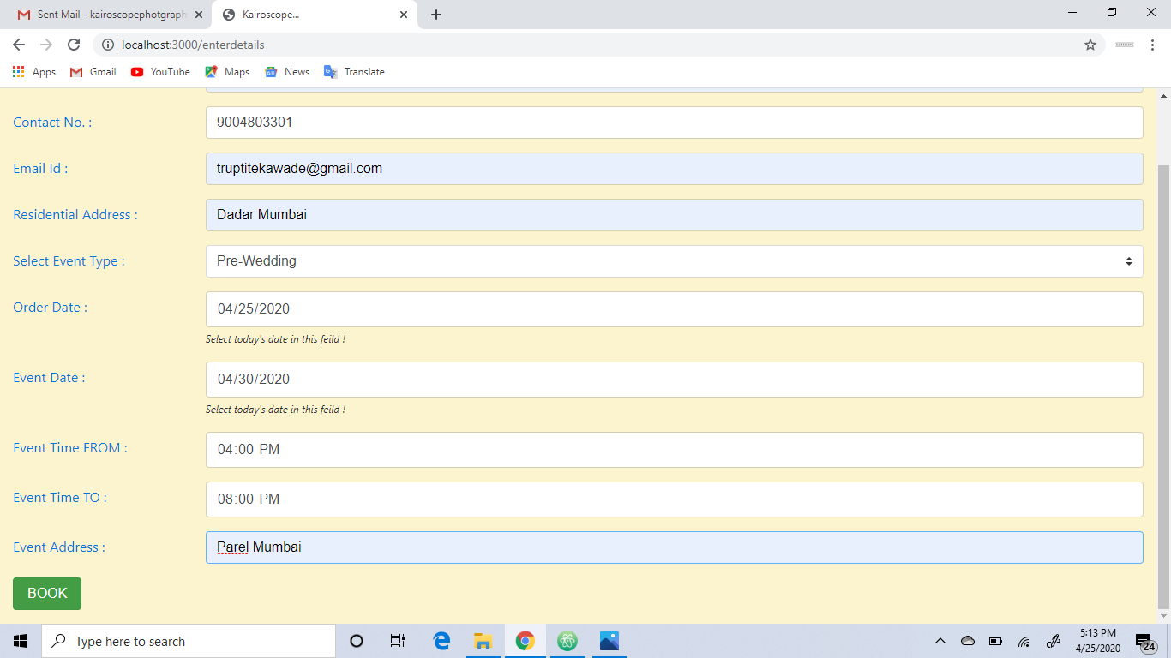

After submitting this form, the order details are stored successfully in the database.

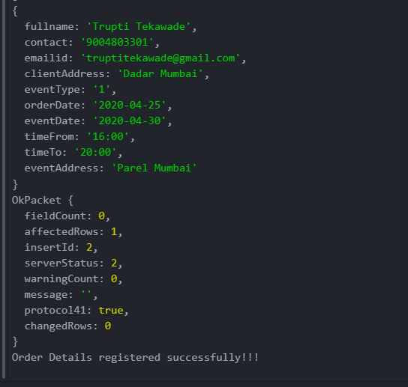

After filling the details correctly the below message is shown to the customer, to inform that his/her order is placed successfully.

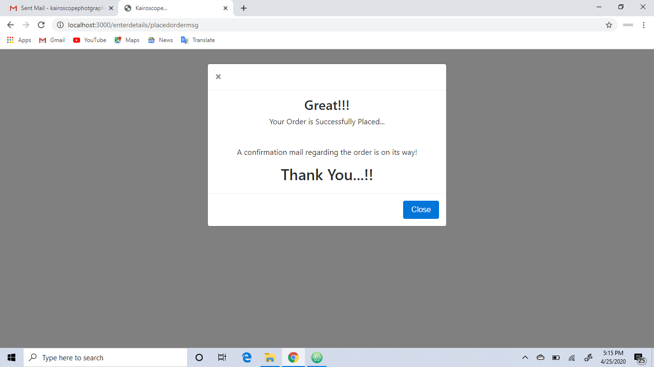

**Admin Working**

Admin will basically edit the cost of the event, check the pending orders, decide whether to accept the order according to the time availability and can also decline the order if we are already booked at that particular day.He will upload the pictures, in order to impress customers.

When the admin clicks on the Admin button, he is navigated to the Admin Login page.

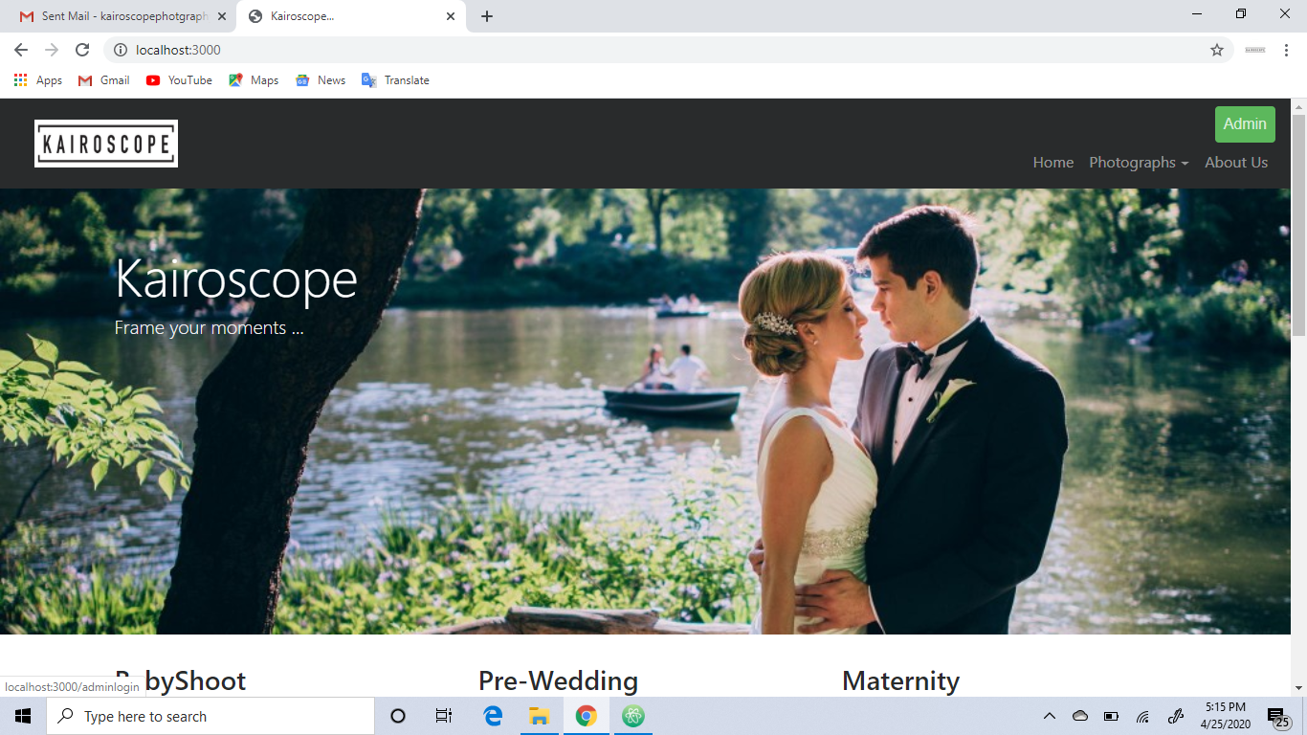

Admin Login Page

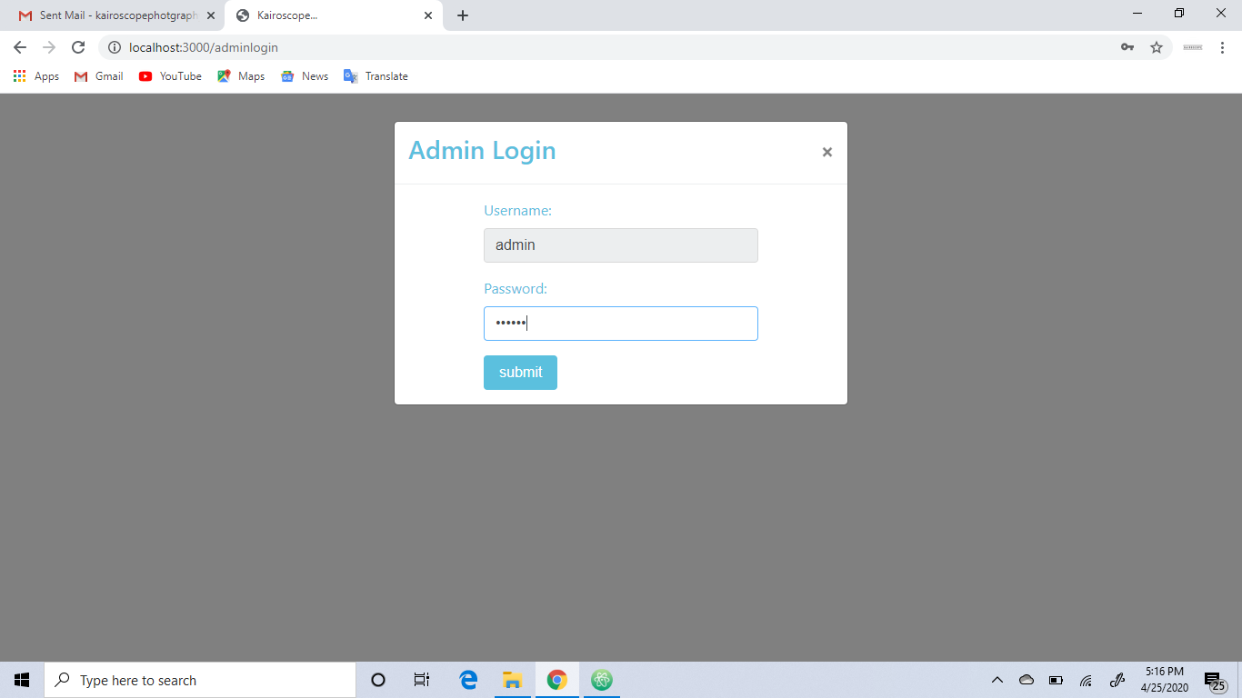

If the admin credentials are correct, then he will be navigated to the admin-panel which is as follows:

Here, the home page of admin consists of the pending orders, confirm orders and completed orders.

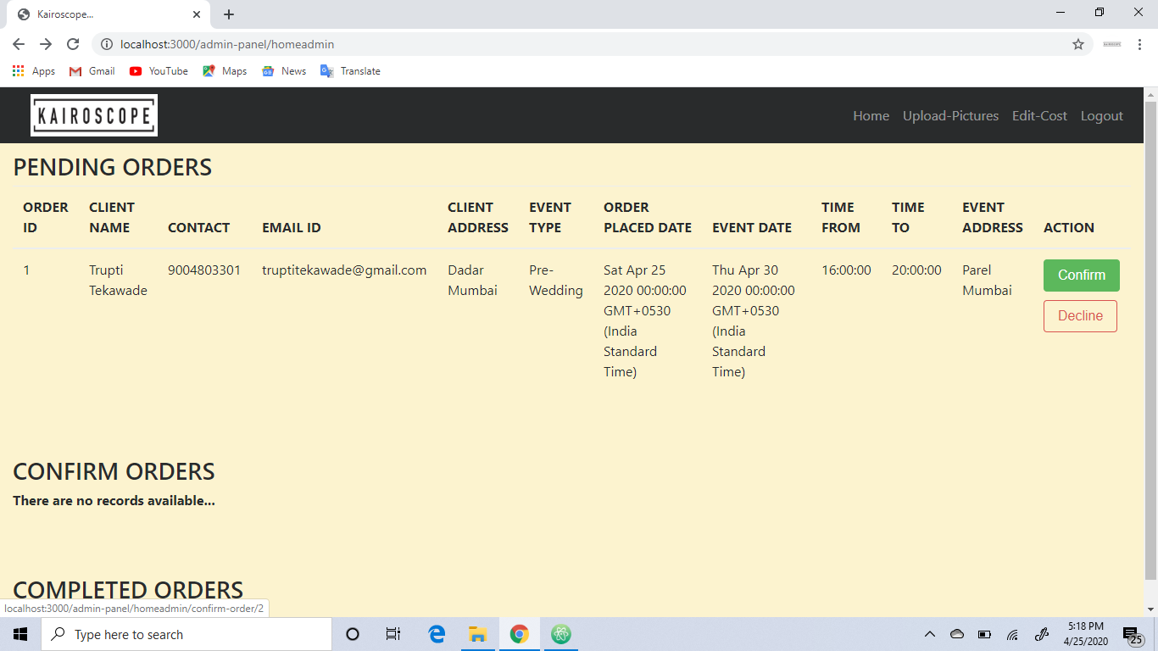

In pending orders, admin decides whether to confirm/decline the order, if he confirms the order a order confirmation mail is sent to the client as follows:

When the confirm button is clicked, admin is navigated to the page below to make sure about order confirmation.

Confirm Order Page

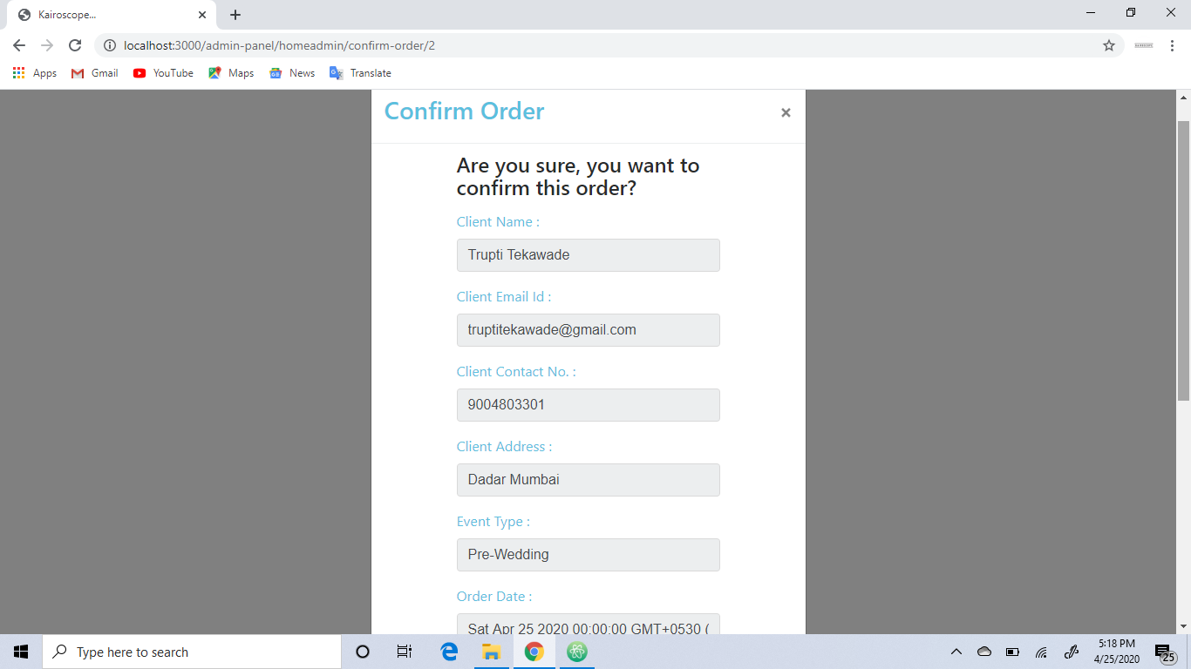

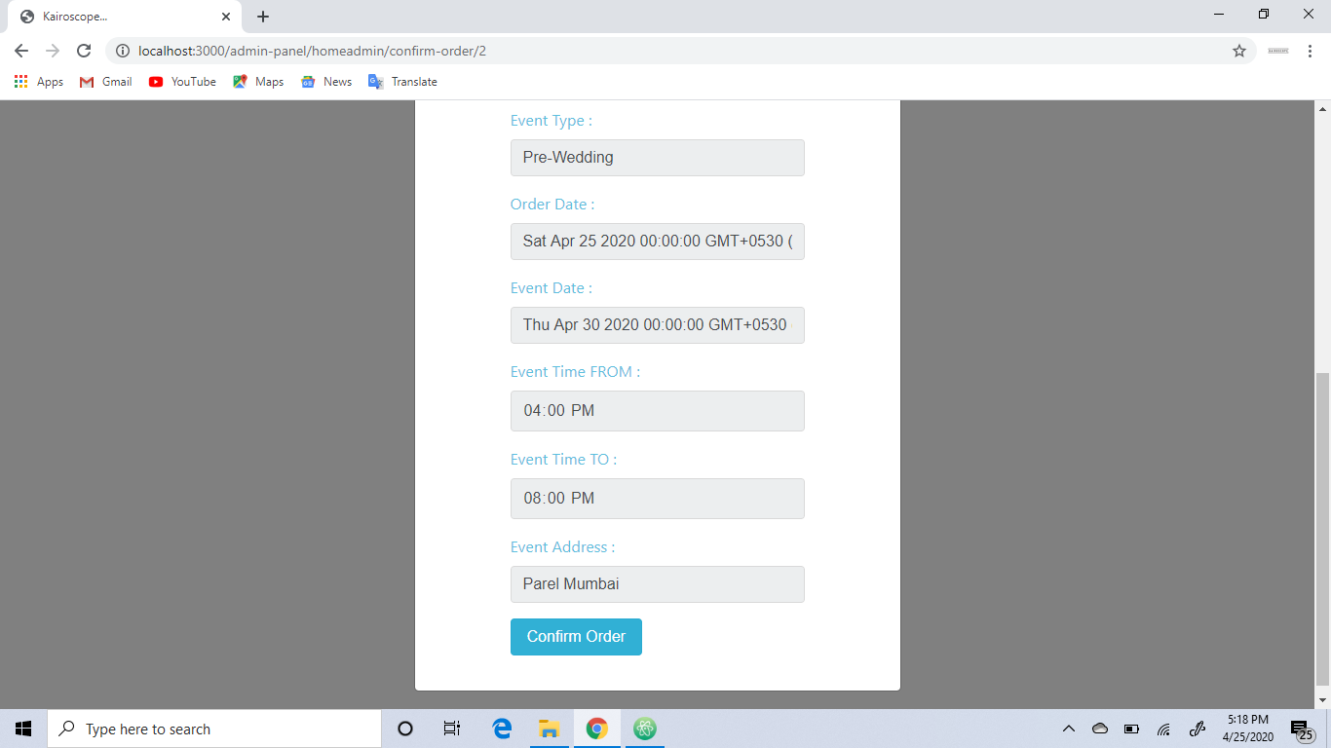

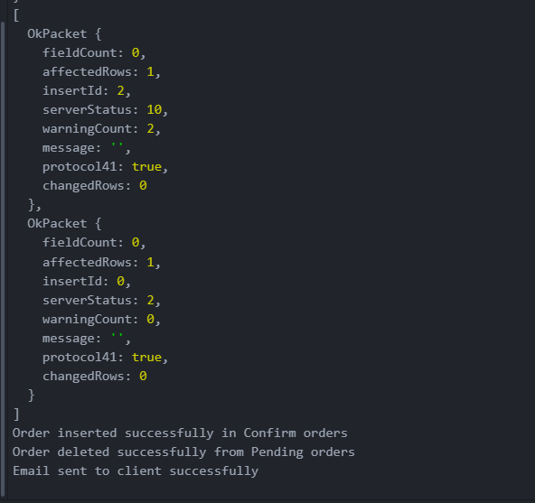

Order Confirmation Mail

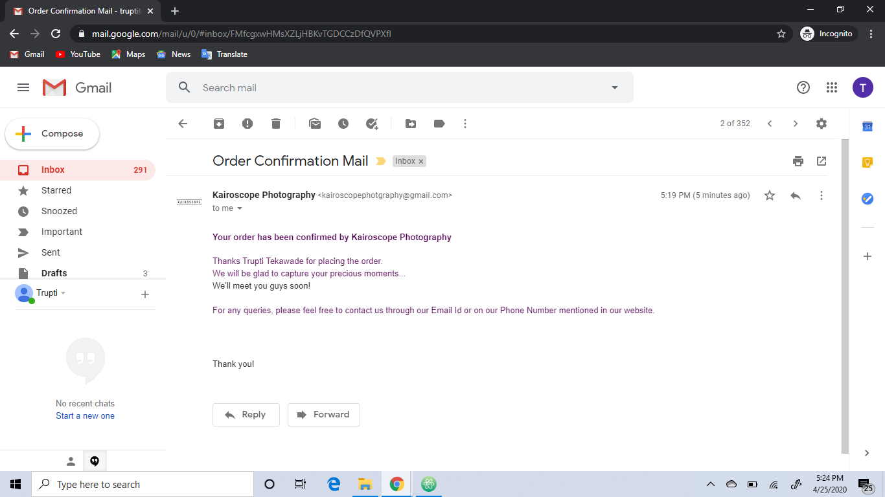

When he/she clicks on decline button, again it is directed to decline order page for surety.

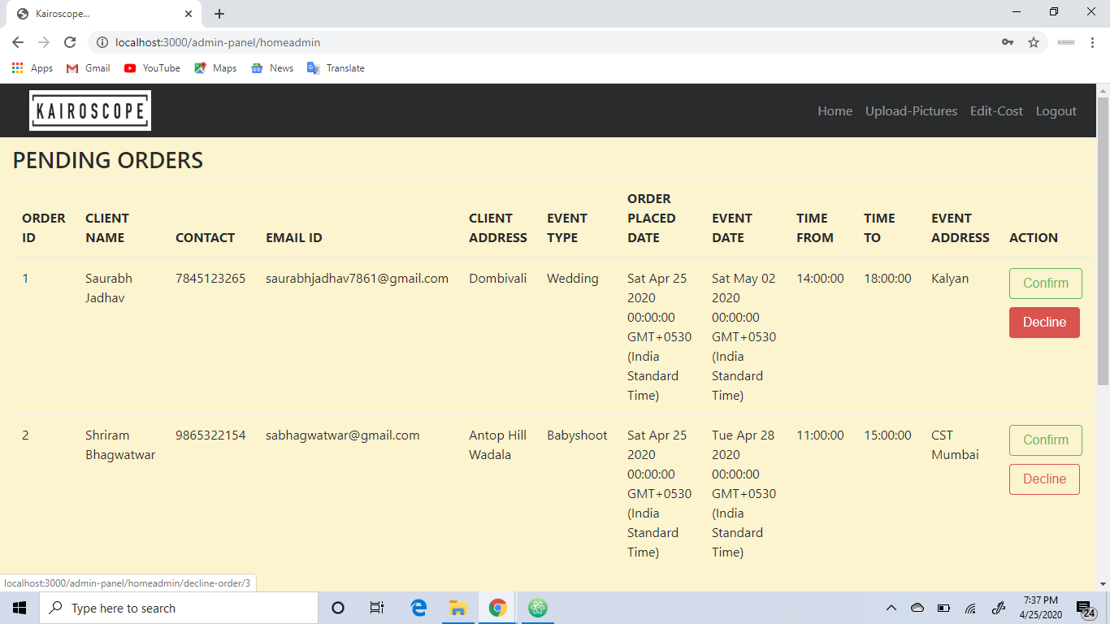

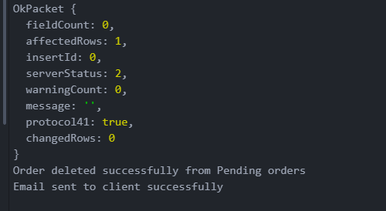

Order Declined Mail

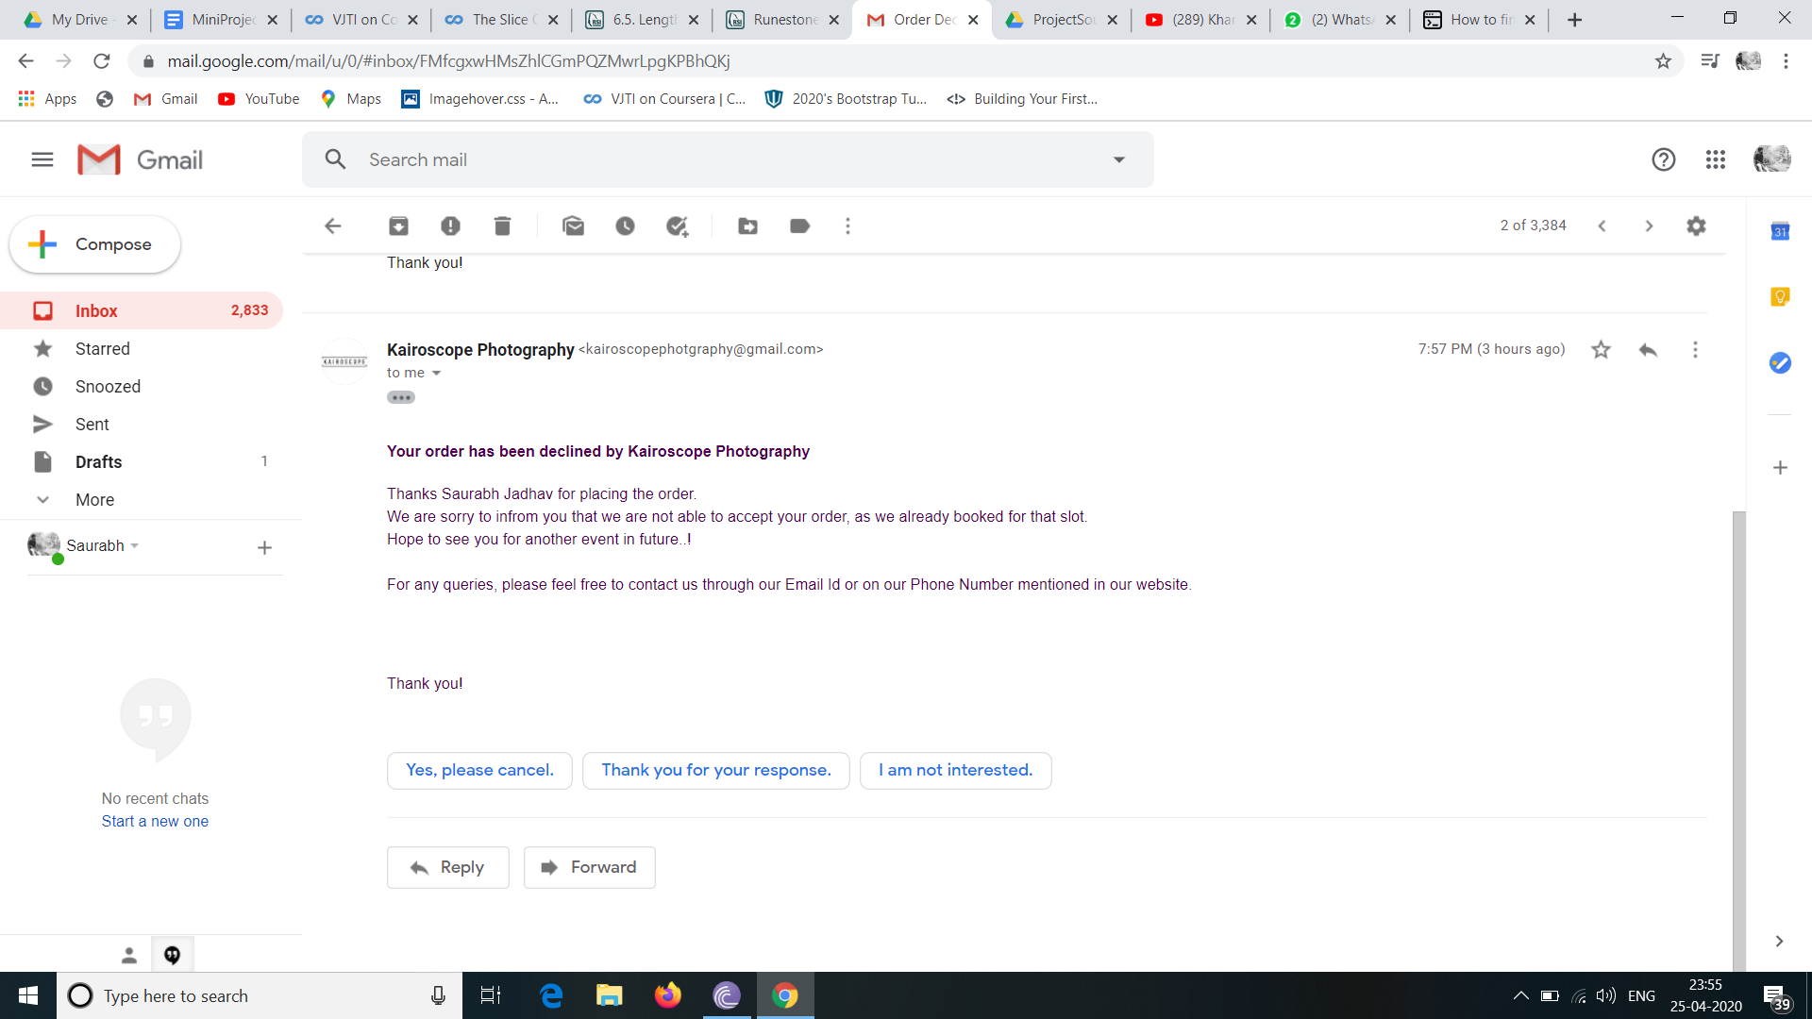

If the order is completed, then the admin clicks on the completed button of the confirm orders table,so that an order completion mail is sent to the client.

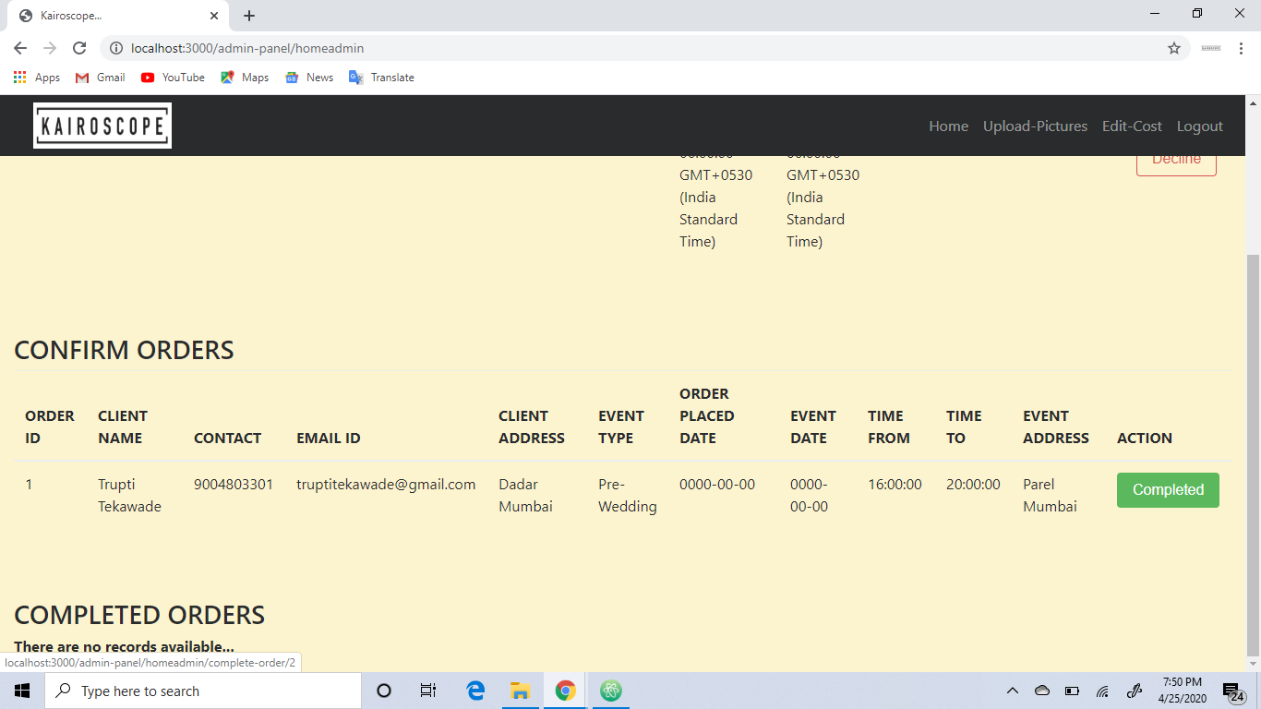

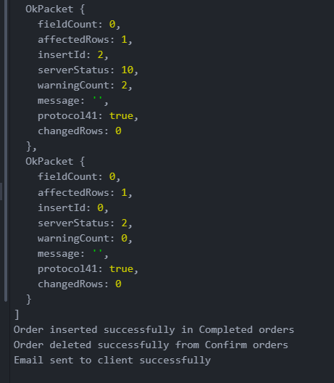

Order Completion Mail

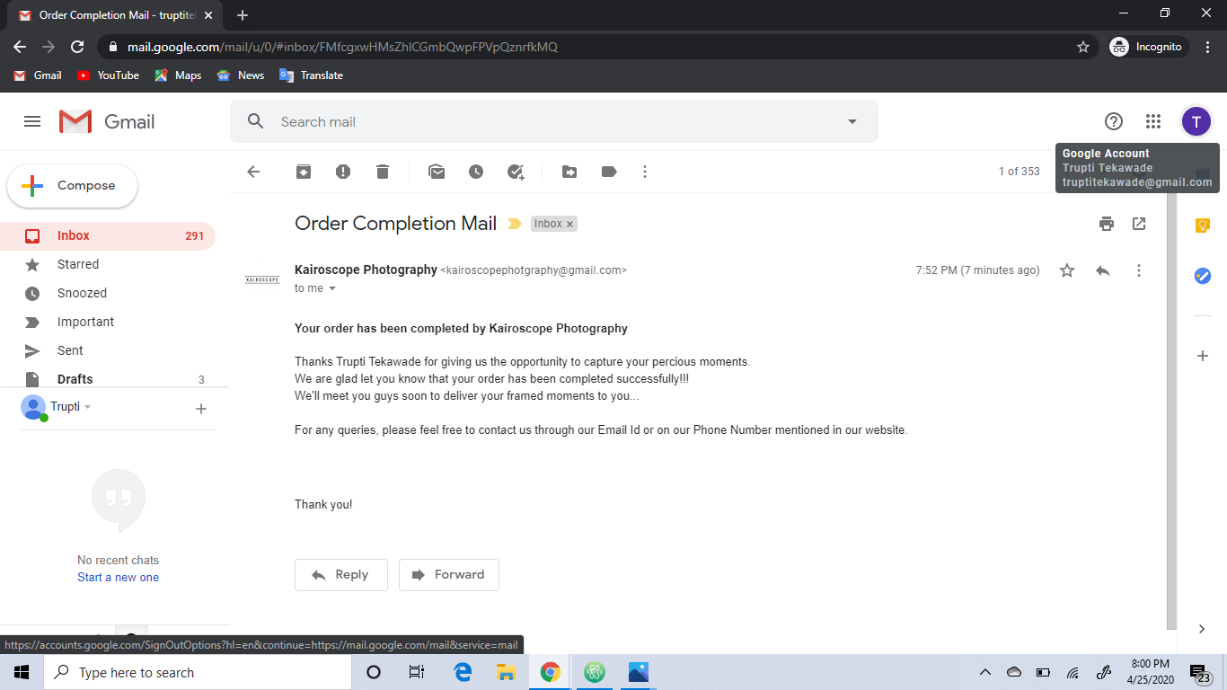

And in the completed orders table the orders that are completed are shown.

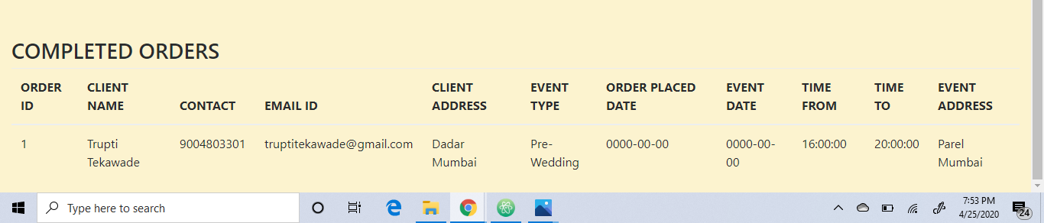

Upload Pictures

Here admin can upload more pictures for customers to see his work, to attract more clients towards him by his work.

For example, we are uploading a file maternity_front.jpg

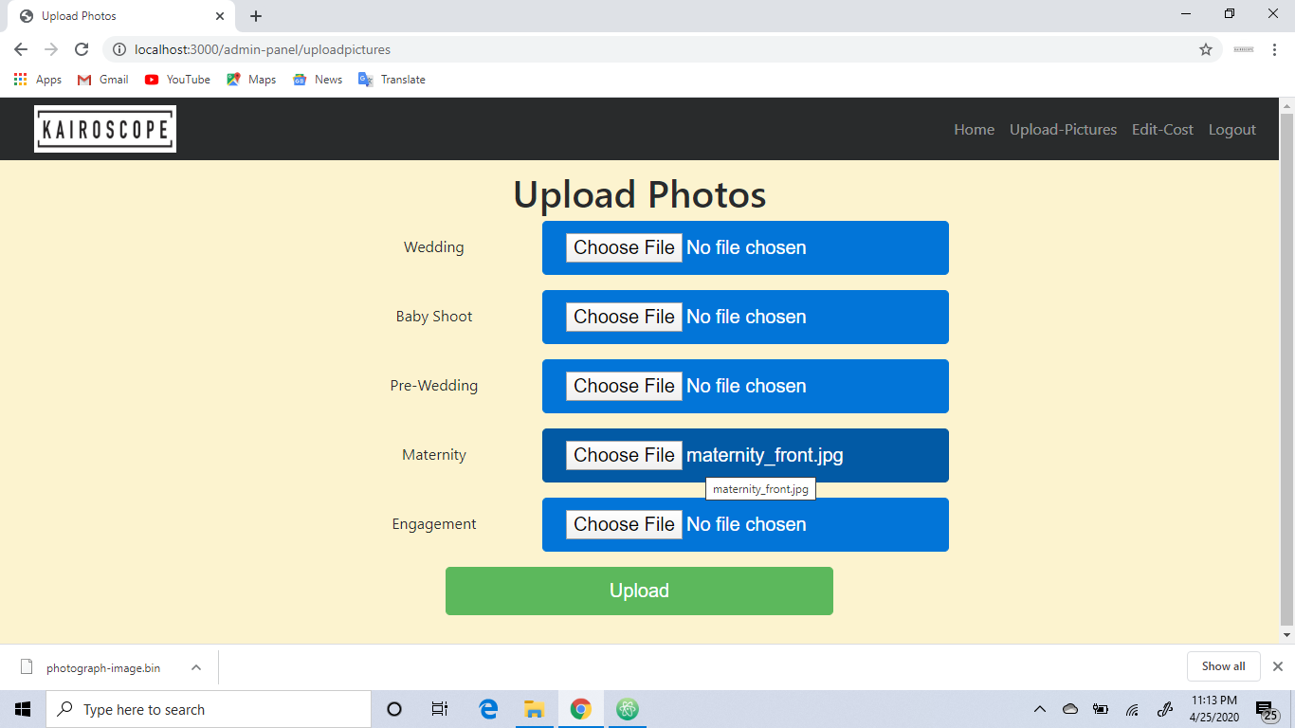

Admin chooses files from his device, which are then uploaded and gets stored in the database.

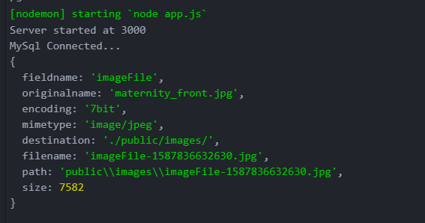

If the file is correctly uploaded he gets the following message.

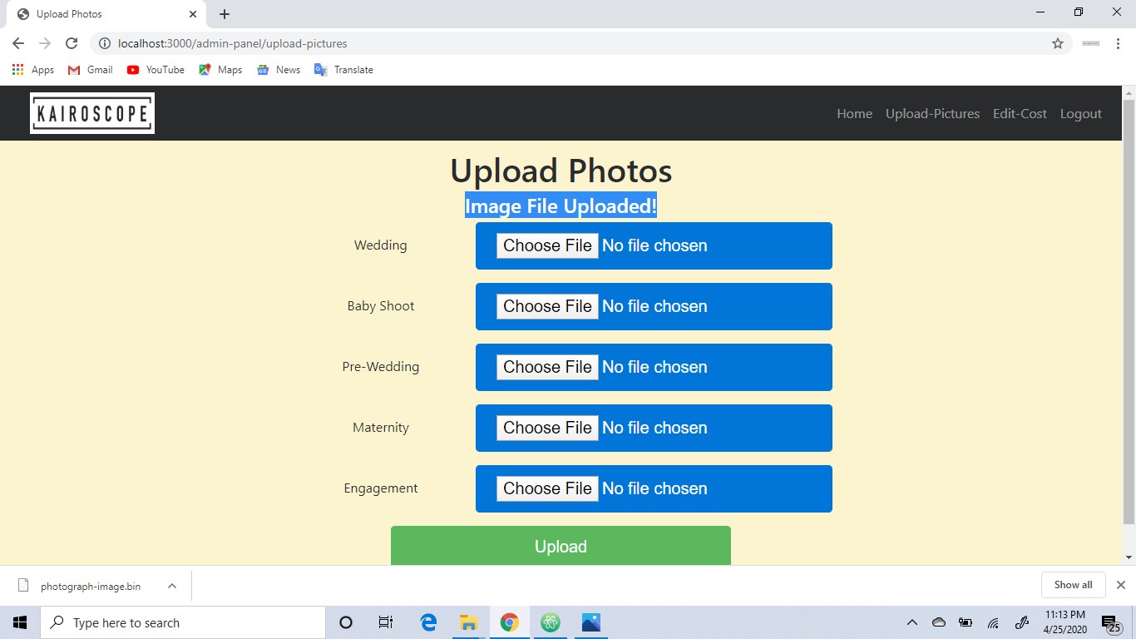

Edit Cost

Here, admin can change the cost of various events, as the cost of anything is not always fixed.

For example, the fee for a pre-wedding event is Rs.6000. If the admin wants to change the cost he can change it by clicking on the edit button.

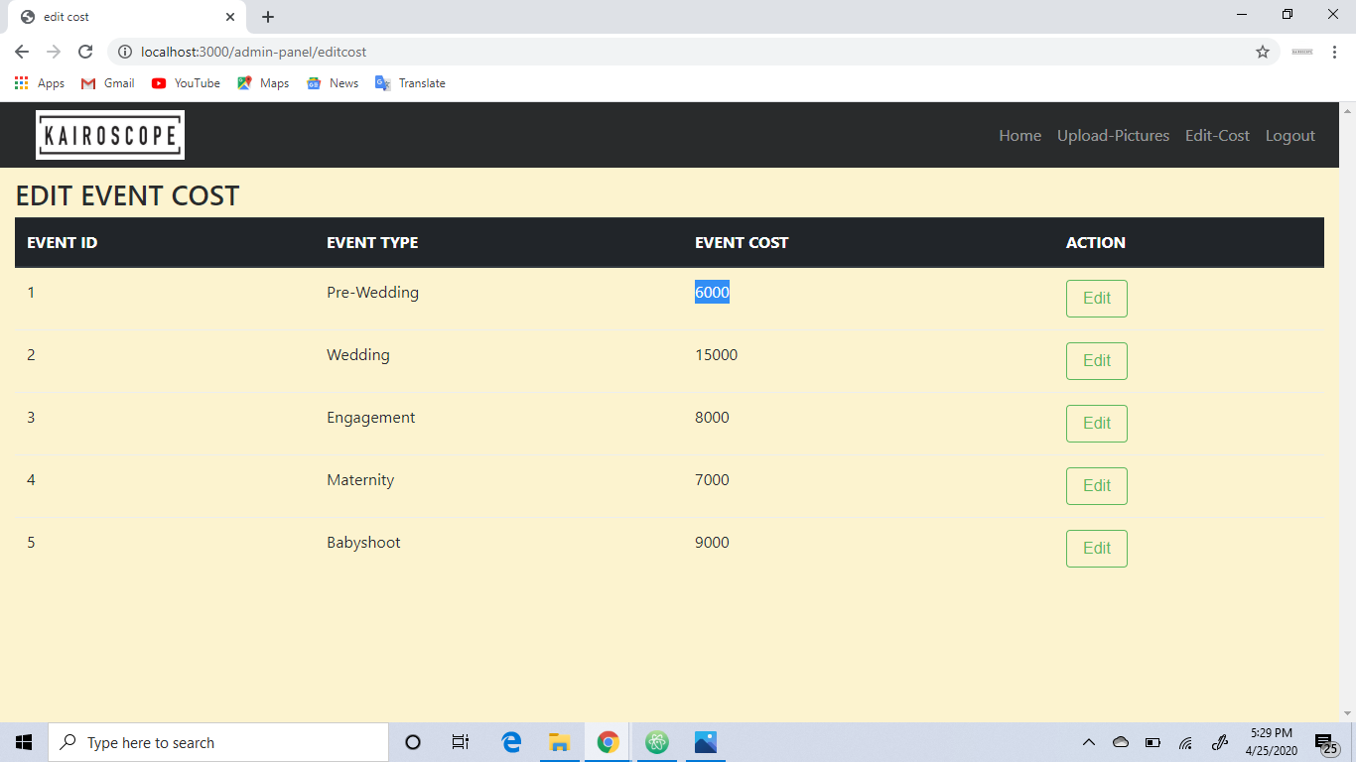

Here admin can enter the required updated amount and save the changes.

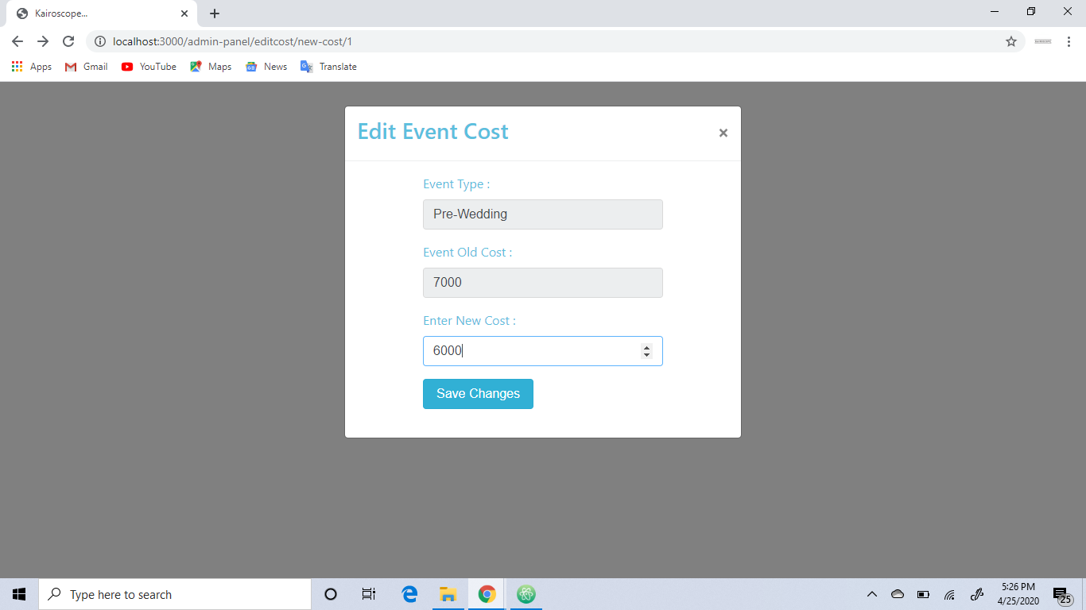

Previously the amount was Rs.6000 and after updation it became Rs.7000.

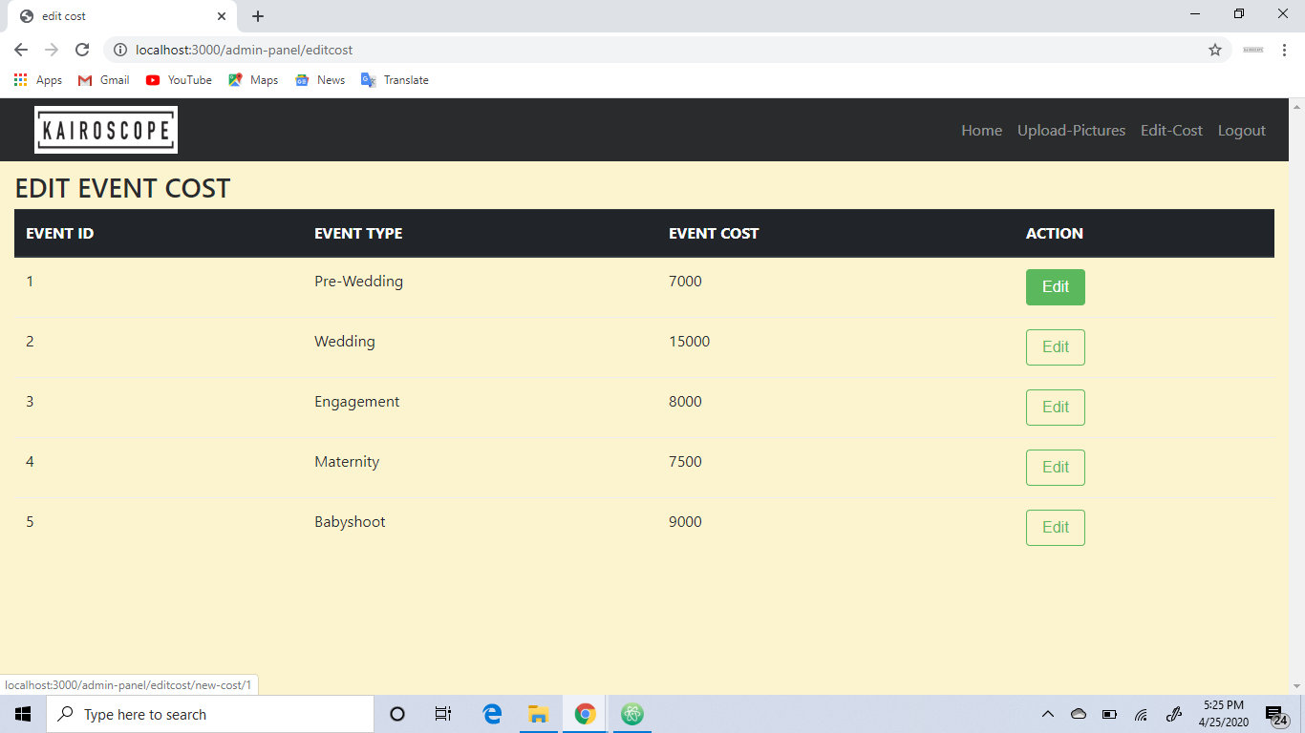

These changes are made to the database and we get the following message on updating the amount.

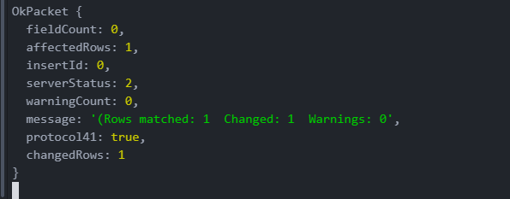

And finally when the admin clicks on the logout button, he is out of the admin panel and is redirected to the homepage at client side.